**Auction Management System**

Dr/ Hazem Marwan

[hazem.marawan@hotmail.com](mailto:hazem.marawan@hotmail.com)

1. Gamal Abdel-Moneam Elsawy (section 5)
2. Bassam Saber Megahed Mansour (section 5)
3. Hisham Gamal Abdel-Qawy (section 17)
4. Kareem Abdel Wahab Abdel Halim (section 12)

Date:-

1. Initial Design :

1-User:

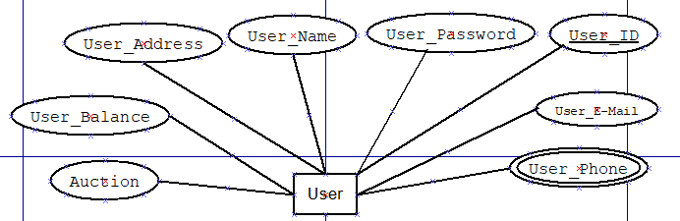

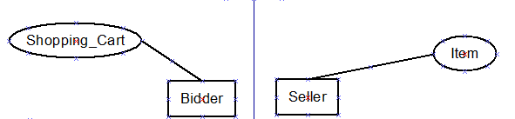

-Bidder and Seller is a weak entity. shopping_cart_id, item_id with user_id will be key attribute.

2-Category:

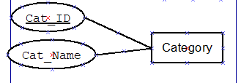

3-Item:

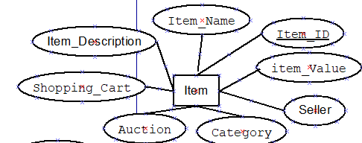

4-Shopping_Cart:

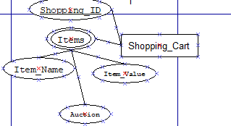

* Items is a multivalued with attribute item name and item value from last bid and auction id that item participate in it.

5-Auction:

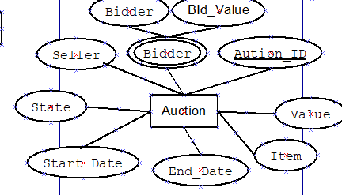

-Bidder is a multivalued because a lot of user can bid in the same item with its bigger value and his id

-State: have 2 value open and closed

1. ER-Diagram:

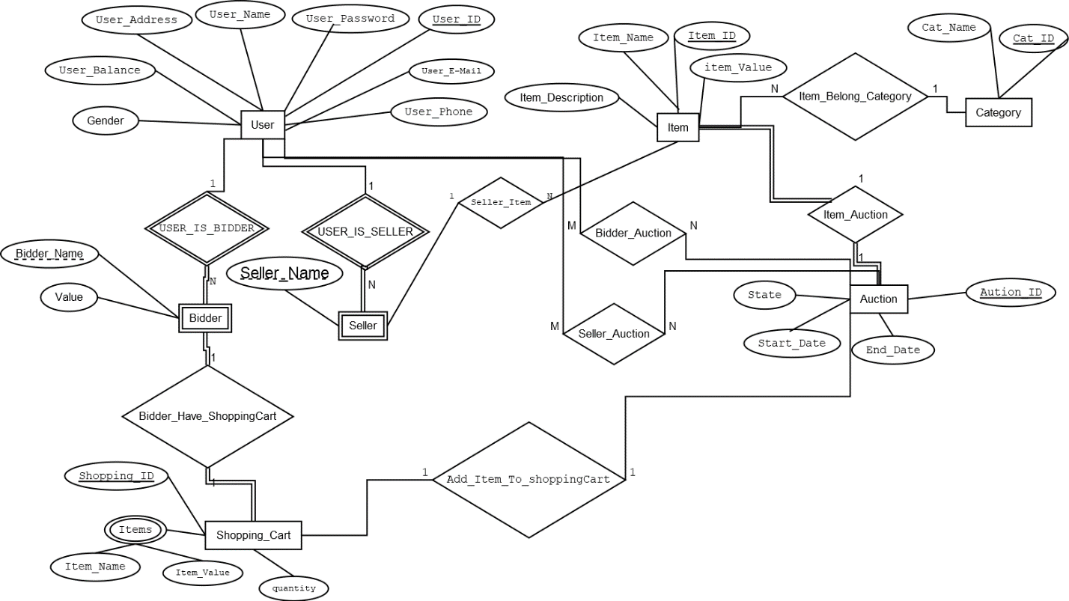

1. Assumption Relations:

* (Bidder_Have_ShoppingCart) one shopping cart belong to one bidder but bidder have a lot of shopping cart
* (Add_Item_To_ShoppingCart) add Auction’s item to shopping cart of largest bidder.
* (seller auction) seller can perform more than auction and auction performed by many auctions on various of items
* (bidder auction) bidder can bid on more than auction’s item in the same time
* (item Auction) one to one because one item belongs to one auction only
* (item_Belongs_Category) one item belongs to one category and one category include a lot of items

(4)Scripts(Querys):

create table USERS(

USER_ID Number Primary key,

Name varchar(14),

Phone Number(11),

Address varchar(50),

Balance Number,

E_Mail varchar(20),

Password varchar(100),

gender varchar(10)

);

create table BIDDERS(

User_ID Number ,

Bidder_Name Varchar(14) primary key,

Value NUMBER

);

create table SELLERS(

User_ID Number ,

Seller_Name Varchar(14) primary key

);

create table SHIPPING_CARTS(

ship_id Number primary key,

Quantity Number,

Bidder_ID Number

);

create table SHIPPING_ITEMS(

ship_id Number ,

itm_Name varchar(14) primary key ,

Value Number,

Auc_ID Number

);

create table ITEMS(

ITEM_ID Number primary key ,

Name varchar(14) ,

Description varchar(50),

Value Number,

Seller_ID Number,

cat_Id Number

);

create table CATEGORIES(

CAT_ID Number primary key ,

Cat_Name Varchar(10)

);

create table AUCTIONS(

AUC_ID Number primary key ,

S_Date DAtE,

E_Date DATE,

Status varchar(8)

);

create table BIDDER_AUCTIONS(

AUC_ID NUMBER ,

USER_ID Number ,

Value Number,

constraint t_pk primary key (AUC_ID,USER_ID)

);

create table SELLER_AUCTIONS(

AUC_ID NUMBER ,

USER_ID Number ,

itm_ID Number ,

constraint t2_pk primary key (AUC_ID,USER_ID)

);

alter table bidders

add foreign key (USER_ID) references USERS(USER_ID);

alter table sellers

add foreign key (USER_ID) references USERS(USER_ID);

alter table SHIPPING_CARTS

add foreign key (Bidder_ID) references USERS(USER_ID);

alter table SHIPPING_ITEMS

add foreign key(ship_id) references SHIPPING_CARTS(ship_id);

alter table ITEMS

add foreign key(Seller_ID) references USERS(USER_ID);

alter table ITEMS

add foreign key(cat_Id) references CATEGORIES(CAT_ID);

alter table SHIPPING_ITEMS

add foreign key(AUC_ID) references AUCTIONS(AUC_ID);

alter table SELLER_AUCTIONS

add foreign key (itm_ID) references ITEMS(ITEM_ID);

insert into users(USER_ID, name, phone, address, balance, e_mail, password, gender)

values (1,'jack',1141248413,'50st new jersy',5000,'j558@yahoo.com','123456789','male');

insert into users(USER_ID, name, phone, address, balance, e_mail, password, gender)

values (2,'sam',018458797,'62st new jersy',5000,'j558@yahoo.com','123456789','male');

insert into users(USER_ID, name, phone, address, balance, e_mail, password, gender)

values (3,'maria',0105487,'100 st madint nsr',2500,'maria558@gmail.com','000000001','female');

insert into users(USER_ID, name, phone, address, balance, e_mail, password, gender)

values (4,'alison',002579846512,'150 st berlin ',3000,'alio@gm.com','8125458','female');

insert into sellers(seller_name, user_id)

Values('jack',1);

insert into sellers(seller_name, user_id)

Values('maria',3);

insert into bidders(bidder_name, user_id)

Values('sam',2);

insert into bidders(bidder_name, user_id)

Values('alison',4);

insert into categories(cat_id, cat_name)

Values(1,'cars');

insert into categories(cat_id, cat_name)

Values(2,'books');

insert into categories(cat_id, cat_name)

Values(3,'Mobiles');

insert into categories(cat_id, cat_name)

Values(4,'Computertools(HW)');

insert into items(item_id, name, description, value, seller_id, cat_id)

Values(1,'honda','new car with low used',1000,1,1);

insert into items(item_id, name, description, value, seller_id, cat_id)

Values(2,'KeyBoard','Original Key Board with smart Keys ',500,3,4);